Title: Building general-purpose (GP) ensemble systems with heterogeneous ensembles and deep learners
Sheryl Brahnam
Abstract
Until rather recently, the trend in machine learning (ML) has been primarily focused on building optimal classification systems for very specific and well-defined problems. Research centered on building generic ML systems robust enough to tackle diverse types of data and a large variety of different problems has been curtailed, in part, by Wolpert’s famous “no free lunch” (NFL) theorem, which claims, in effect, that there is no single stand-alone classification approach that can optimally solve every classification problem since a given classification approach works optimally only for a specific subset of classification problems. In other words, Wolpert is claiming that it is impossible to develop a stand-alone classifier that works well across each possible problem. The NFL theorem has been hotly debated and recent research into heterogeneous ensembles combined now with deep learners is beginning to undermine NFL, at least in so far as image recognition is concerned—including any problem that can be treated as an image.
In this address, I will describe some cutting-edge research into building general-purpose (GP) ensemble systems by an international group of researchers from the University of Padua, Università di Bologna, and Missouri State University, specifically Drs. Loris Nanni, Alessandra Lumini, Stefano Ghidoni, and myself. Our vision of an ideal GP system is one that would work well straight out of the box, require little to no parameter tuning, yet would still perform competitively against (if not better than) less flexible systems that have been optimized for very specific problems and datasets. In this talk, I will provide a review of some of our recent successes building GP systems and present some new results produced for this conference.
The overarching goal of this presentation, however, will be to encourage those in attendance to do research in this exciting area. Powerful GP ensembles are of value to the general practitioner and expert alike. At the very least, GP classifier systems can serve as a basis for rapidly building new systems optimized for very specific (but related) problems. The fusion of ensembles of handcrafted features with deep learning systems, for example, can outperform deep leaners alone in small to medium size datasets. Moreover, GP ensembles can further our general understanding of the domains to which they are applied.

Biography

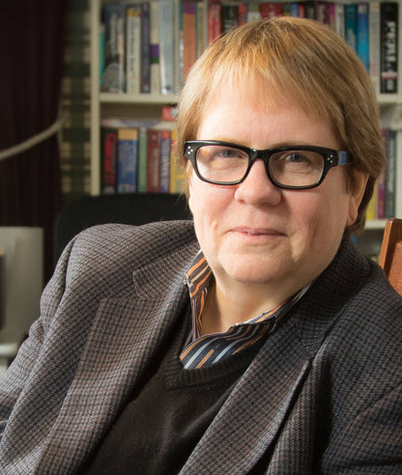
Sheryl Brahnam is a Professor and Daisy Portenier Loukes Research Fellow in the school of COB Computer Information Systems Department at Missouri State University. She is the Director/Founder of Missouri State University's infant COPE (Classification of Pain Expressions) project. Her interests focus on medical decision support systems, machine learning, bioinformatics, biometrics, embodied conversational agents, and computer abuse. She has served as guest editor of several books and special issues on virtual reality and rehabilitation, technologies for inclusive well-being, agent abuse, and computational systems for medicine. She has published extensively in such journals as Bioinformatics, Pattern Recognition, Artificial Intelligence in Medicine, Amino Acids, Journal of Theoretical Biology, Expert Systems with Applications, Decision Support Systems, NeuroComputing, PLos One, and Interacting with Computers, as well as in many conferences devoted to human-computer interaction, machine learning, and artificial intelligence. More about Sheryl Brahnam can be found here: http://www.brahnam.info.

